Software Requirements Engineering – Lab Report
Sources of Requirements + Kano Model — University Course Registration System
Group: Hudaibia, Sarah Arif, Eshaal Nazir, Abdul Samad
Submitted to: Sir Fahim Muhammad Khan : 24 Sept 2026

1. What we did
For this lab we had to find out where the requirements for a new university course registration system should come from, and then use the Kano Model to check how students actually feel about some possible features of it. We picked 8 sources, listed 10 candidate features, made a Kano questionnaire out of them, sent it out, and got 40 responses back. Below is everything we found.

2. Sources of requirements (8)
Source | Example | What we get from it
Students | The people who will actually use the system | What they need, what annoys them now
Registrar office | Registration staff | Rules, approvals, policies
Faculty | Course instructors | Prerequisites, seat limits
IT staff | University IT department | Security, servers, technical limits
Current system | The old manual process | What already works, what doesn't
Academic policies | University rules and deadlines | What the system must follow
Watching students register | Observing registration week | Real problems people run into
Survey | Our Kano questionnaire | What students actually want most

3. Candidate features (10)
These are the 10 features we picked, based on the sources above, and later put into our survey.
No. | Feature
1 | Search courses by code/title/department
2 | Show remaining seats
3 | Registration confirmation
4 | SMS/email notification
5 | Automatic course recommendations
6 | Dark mode
7 | Download timetable as PDF
8 | Remember selected courses
9 | Save data if network drops
10 | Fast response at peak times

4. The Kano questionnaire
For each of the 10 features above we made two questions, one asking how the student would feel if the feature WAS there, and one asking how they'd feel if it was NOT there. Both used the same 5 answers: I like it / I expect it / I am neutral / I can tolerate it / I dislike it. We built this in Google Forms, titled "Kano Analysis — University Course Registration System", tested it ourselves first, then sent it out to students.
Form link: [paste your Google Form link here]

5. How we classified answers
We used the standard Kano table below to turn each pair of answers into one letter (A/O/M/I/R/Q). This was done in a spreadsheet, not by hand, for all 40 responses.
Have it \ Don't have it | Like | Expect | Neutral | Tolerate | Dislike
Like | Q | A | A | A | O
Expect | R | I | I | I | M
Neutral | R | I | I | I | M
Tolerate | R | I | I | I | M
Dislike | R | R | R | R | Q

6. Results (n = 40)
A few people skipped a question or two here and there, so those specific answers were left out and not counted for that one feature.
Feature | A | O | M | I | R | Q | Dominant
Course search | 15 | 11 | 1 | 8 | 0 | 4 | Attractive
Seat display | 12 | 9 | 4 | 9 | 0 | 4 | Attractive
Registration confirmation | 5 | 12 | 5 | 10 | 2 | 4 | One-dimensional
SMS/email notification | 9 | 9 | 2 | 13 | 1 | 4 | Indifferent
Course recommendations | 8 | 8 | 1 | 12 | 3 | 4 | Indifferent
Dark mode | 6 | 8 | 1 | 13 | 5 | 6 | Indifferent
Download timetable | 8 | 11 | 5 | 7 | 1 | 6 | One-dimensional
Remember courses | 9 | 8 | 3 | 10 | 3 | 4 | Indifferent
Data preservation | 5 | 8 | 3 | 10 | 3 | 8 | Indifferent
Fast peak response | 7 | 12 | 5 | 9 | 1 | 5 | One-dimensional
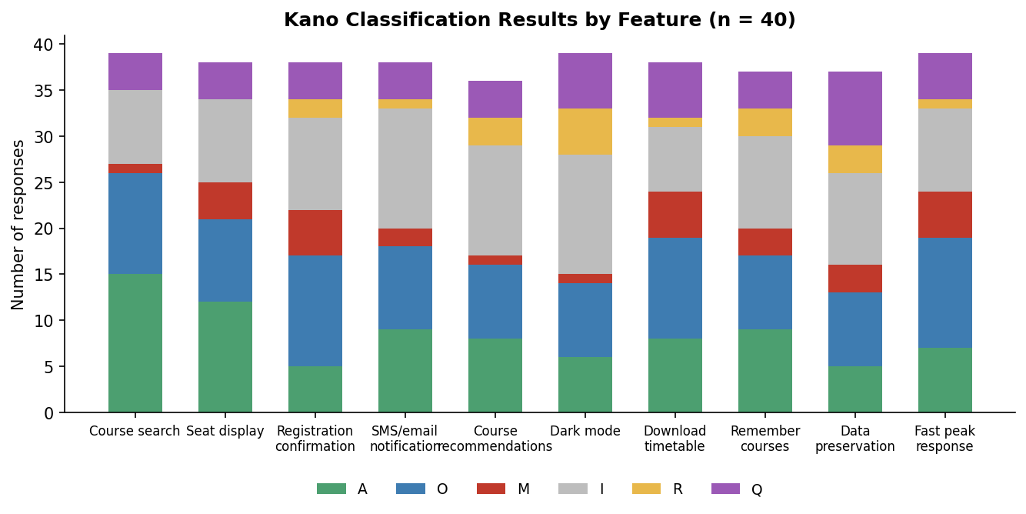

7. What the results mean
Course search and the seat display came out as Attractive, students like having them but won't get too mad if they're basic, though for this system we'd still build both early since the whole app is built around them. Registration confirmation, downloading the timetable, and fast response at busy times all came out One-dimensional, so the better we do these, the happier students are, and the worse we do them, the more they complain. Everything else, notifications, recommendations, dark mode, remembering courses, saving data during network issues, came out mostly Indifferent, students don't care much either way.
Questionable example: "Save data if network drops" had the most Questionable answers (8 out of 40). We think it's because the question describes a specific situation and not everyone imagined the same thing when answering both parts, so their answers ended up contradicting each other.
Indifferent example: Dark mode had the most Indifferent answers (13 out of 40). Makes sense, it's just a look/theme thing and has nothing to do with actually registering for a class, so most people don't really care if it's there or not.

8. Does this decide what we build first?
Not on its own. Kano only tells us how students feel, it doesn't account for cost, time, or how hard something is to build. So even though course search is "just" Attractive, we'd still build it first since nothing else works without it. And something like dark mode being Indifferent means it's fine to leave for last, or skip it completely if we run out of time.

9. Who did what
Name | Worked on
Hudaibia | Requirement sources + feature list
Sarah Arif | Questionnaire + Google Form
Eshaal Nazir | Spreadsheet + classification + chart
Abdul Samad | Write-up + reflection + final report

